# **6. Step: Create Pins Inspired By the Top-Ranking Ones SOP**

## **The steps to efficiently create new images for each KW from your Overview Sheet:**

1. Generate Midjourney prompts with our [AI Image Prompt Generator](https://www.pinscalesystem.com/view/courses/template-sop-automation-collection/2924992-details-step-6-create-high-quality-images-efficiently/9623735-ai-image-prompt-generator) and save them to a Google Spreadsheet, one tab per keyword.

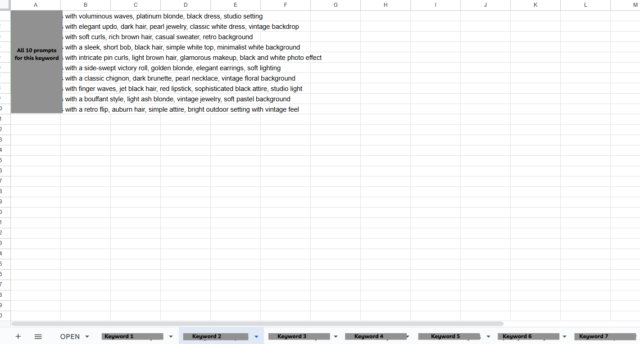

1. Generate the AI images with our [Image Prompt Automation](https://www.pinscalesystem.com/view/courses/template-sop-automation-collection/2924992-details-step-6-create-high-quality-images-efficiently/9623732-image-prompt-automation-s)
2. Download the generated images from Midjourney
3. Unpack the zip files and organize the images into folders.
4. Post-process the images using xnConvert.
5. Shuffle and rename files.
6. Upload images to Google Drive.

## **Step 1: Generate Midjourney prompts**

* Open Pinterest in an incognito tab.
* Enter your keyword for the images you want to generate.  
  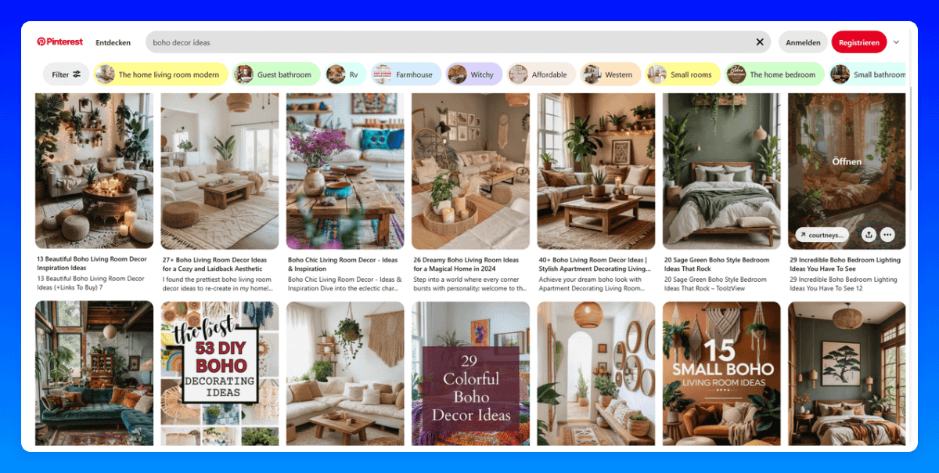
* Download 3 images that rank in the top 10.
* Open the [AI Prompt Generator,](https://pintoolkit.com/tools/prompt-generator) configure your API keys if not already done, and upload the 3 images into the generator.  
  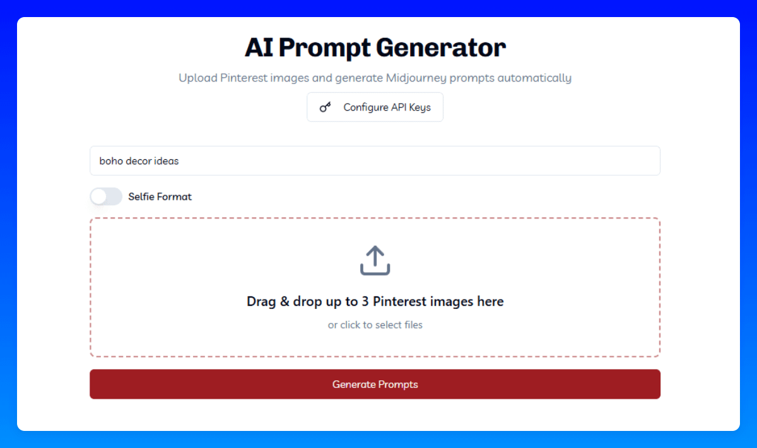
* Click on "Generate Prompts" to start the prompt generation. In less than a minute, you’ll receive 10 prompts like this.  
  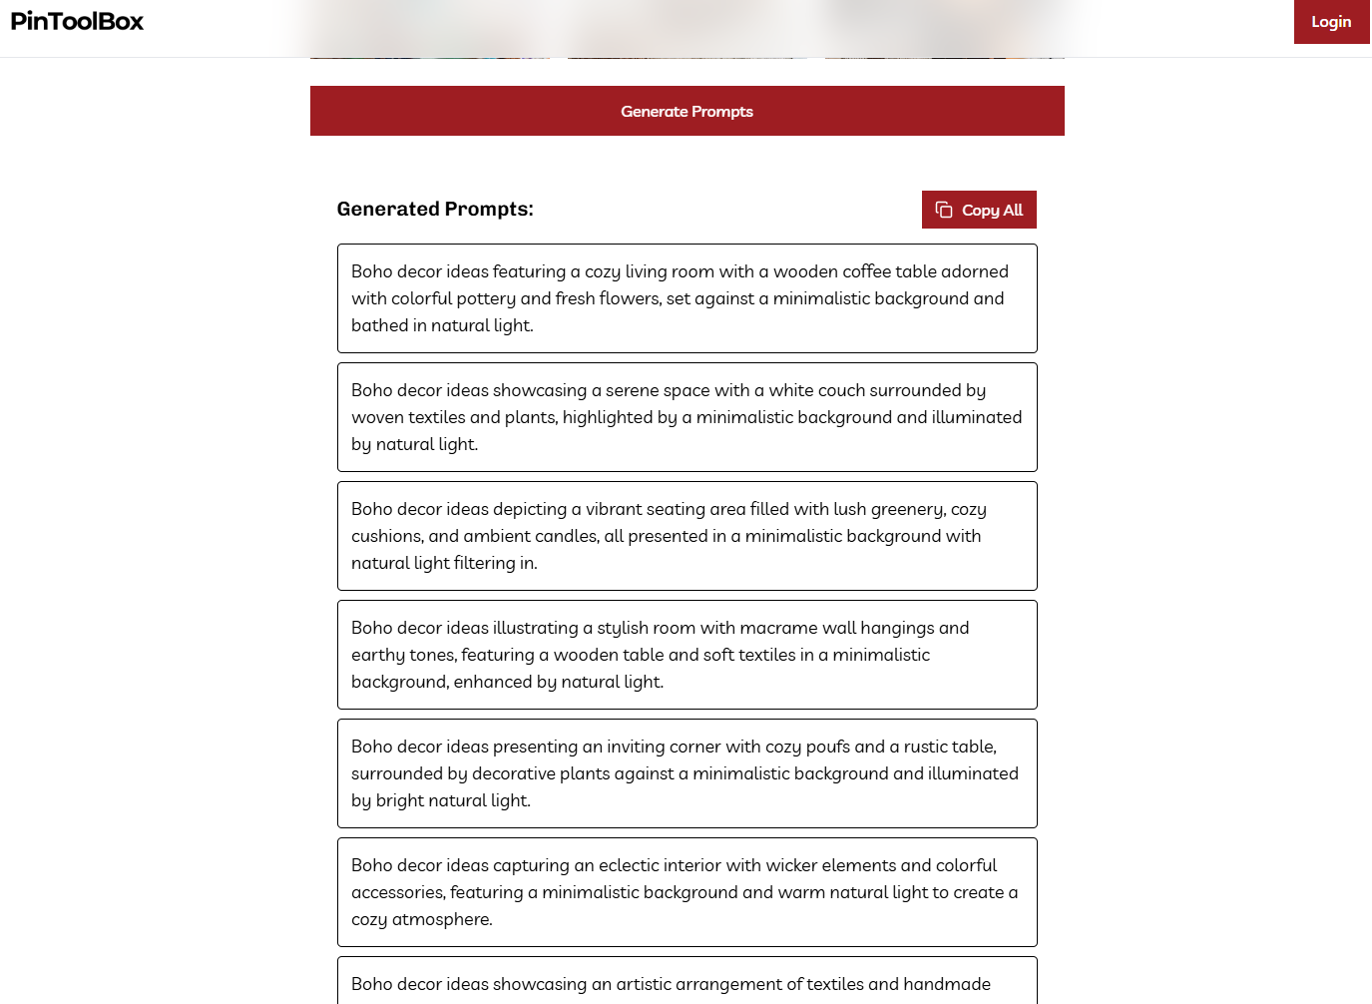
* Click on "Copy All" to copy the generated prompts.
* Open an existing or new Google Spreadsheet.  
  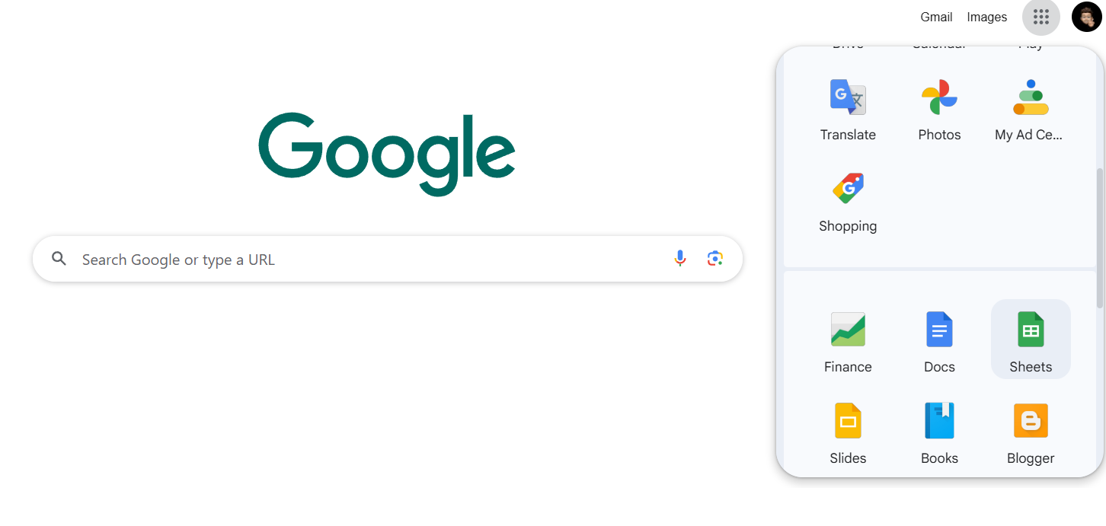
* Paste the copied prompts into the spreadsheet and rename the sheet for better organization.  
  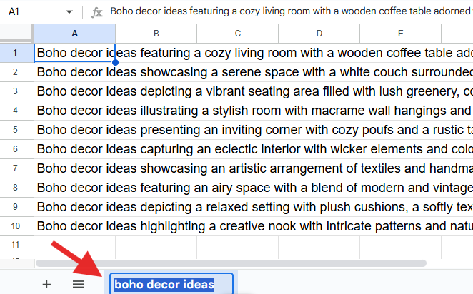
* Generate as many prompts for as many KWs as possible to make the next steps much more efficient!

## **Step 2: Generate images with our Image Prompt Automation**

* ATTENTION: I strongly recommend running the automation on a second PC or at a time when you don’t need your computer—e.g., start it before going to sleep.  
  While the automation is running, your PC will be blocked, making it impossible to use it for other tasks.
* Open [midjourney.com](http://midjourney.com/) in a second browser window and go to Create (Tip: You can similarly do this with [ideogram.ai,](http://ideogram.ai/) especially for text overlay pins[)](http://ideogram.ai/).  
  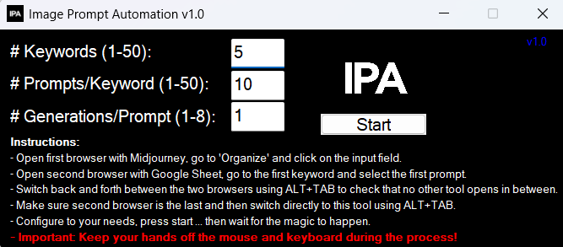
* [Image Prompt Automation.exe(983 KB)](https://s3.us-west-2.amazonaws.com/content.podia.com/v4c7dxed443dusvag2rm5ucaernh)
  + Download the Image Prompt Automation, start it, and configure it according to your needs:
    - Number of Keywords = Number of tabs in your sheet
    - Prompts per Keyword = How many prompts do you have per keyword (we typically use 10)
    - Generations per Prompt = How many images should be generated per prompt
  + Make sure the browser window with Midjourney and the browser window with the Google Spreadsheet are the last two windows you opened, with the Google Spreadsheet being the last one.  
    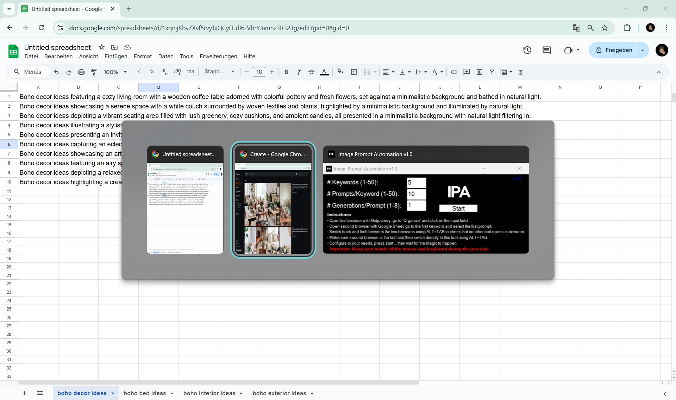
  + Then, switch back to the Image Prompt Automation tool and click Start.  
    🚨 Important: Don't touch your keyboard or mouse while the tool is running!  
    The tool will minimize and automatically copy each prompt from the Google Spreadsheet into Midjourney by simulating keyboard and mouse actions.
  + Once the Image Prompt Automation is finished, you'll receive a short message. From this point on, you can use your mouse and keyboard again.  
    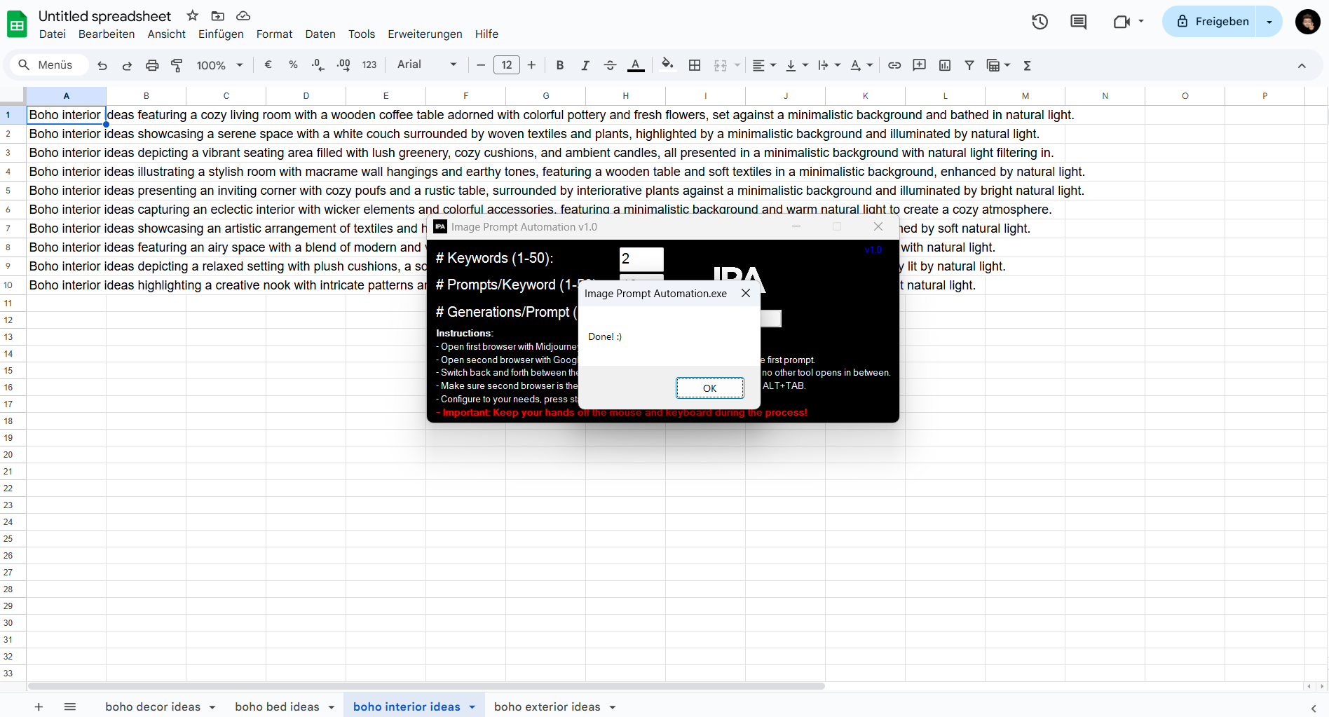
* If you’re new to Midjourney or Ideogram, check out our [Midjourney SOP](https://www.pinscalesystem.com/view/courses/template-sop-automation-collection/2924992-details-step-6-create-high-quality-images-efficiently/9484647-midjourney-s) or [Ideogram SOP](https://www.pinscalesystem.com/view/courses/template-sop-automation-collection/2924992-details-step-6-create-high-quality-images-efficiently/9484648-ideogram-s) for a detailed guide.

## **Step 3: Download images from Midjourney**

* Pro Tip: Download images in batches for each KW. This makes further processing much easier since you won’t have to sort them later (see Step 4).
* If you're using Midjourney:
  + Go to "Organize" and scroll to your most recently generated images.
  + Select all images you want to download by holding the left mouse button or pressing SHIFT while clicking on each image.  
    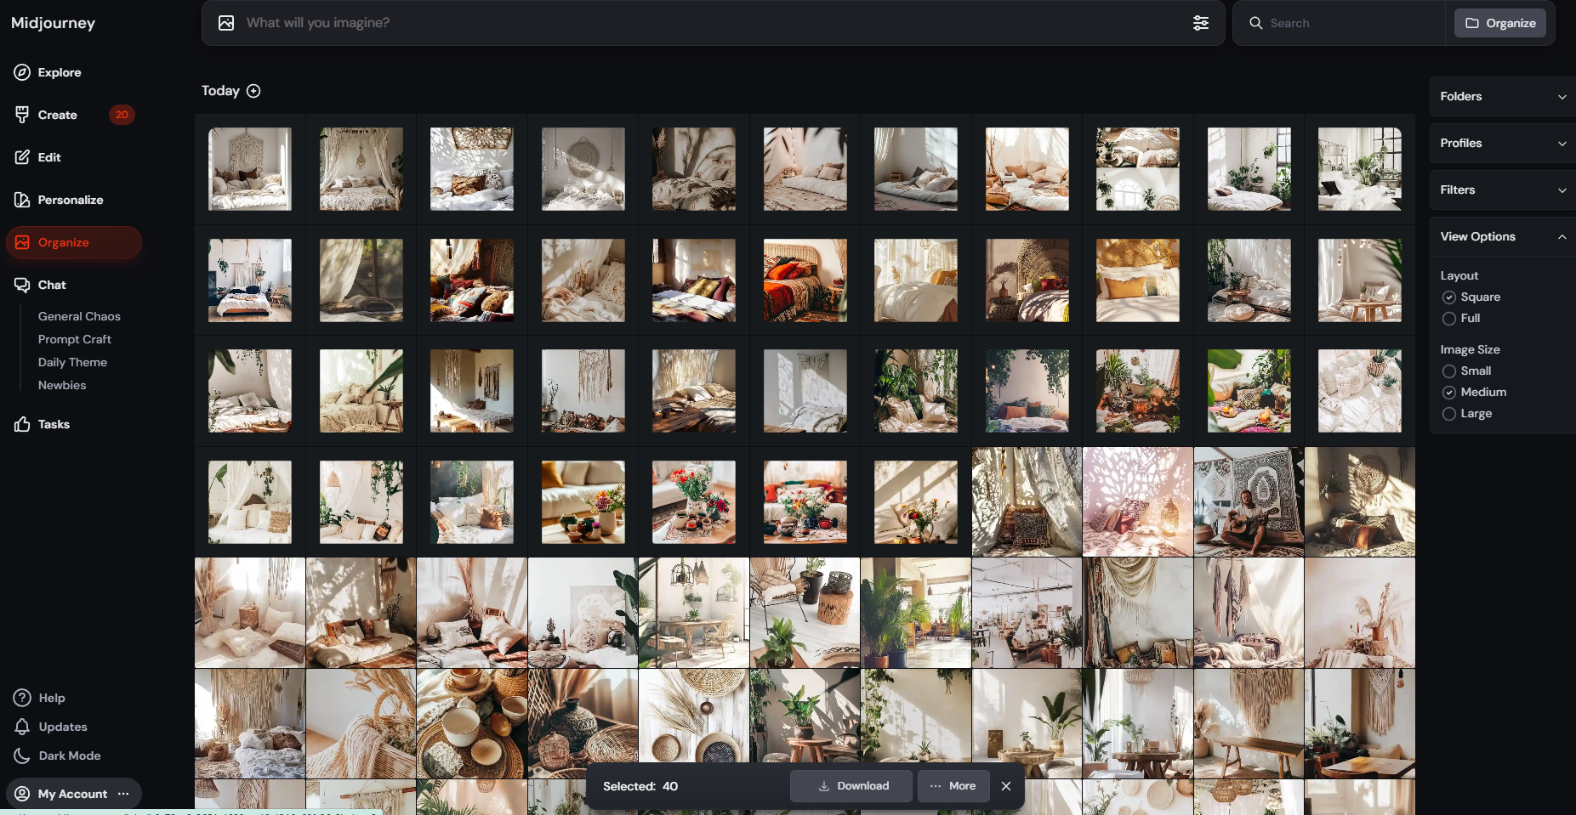
  + When you're done, click "Download", and all images will be packed into ZIP files (50 images per file).
* If you're using Ideogram:
  + Go to "Creations" and scroll to your most recently generated images.
  + Images are grouped in sets of four, so you only need to select one image per group.
    - To download multiple images, left-click the white checkbox on one image from each group.
    - Alternatively, left-click below the images, hold the click, and drag to select multiple images at once.
  + 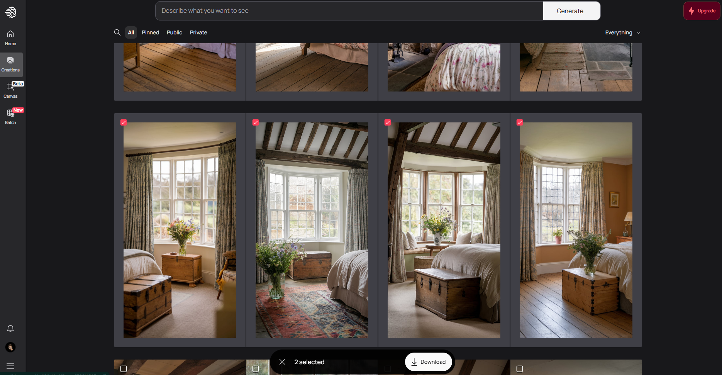
* When you're done, click "Download", and all images will be packed into ZIP files (maximum 50 images per file).  
  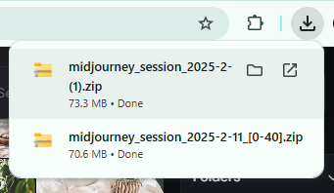
* Move the downloaded ZIP files to a designated folder where you want to process them—we recommend using C:/Temp for easy access.  
  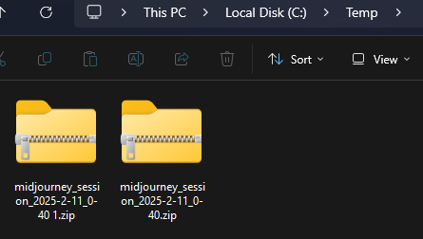

## **Step 4: Unpack Your Images and Sort Them into Folders**

* Unzip all .zip files using a ZIP tool of your choice, or save time by using [our batch file for bulk extraction](https://www.pinscalesystem.com/view/courses/template-sop-automation-collection/2924992-details-step-6-create-high-quality-images-efficiently/9623747-script-package-unpack-high-amount-of-zip-files-shuffle-rename-files-s):
  1. Download the batch file "rename_and_unpack.bat"
  2. Copy it into the same folder where all ZIP files are stored (e.g., C:/Temp)  
     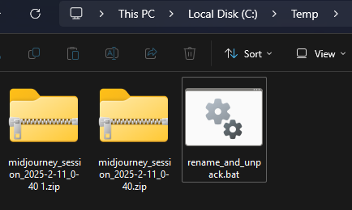
  3. Run the batch file, for the first time you might get a warning, click on "More info".  
     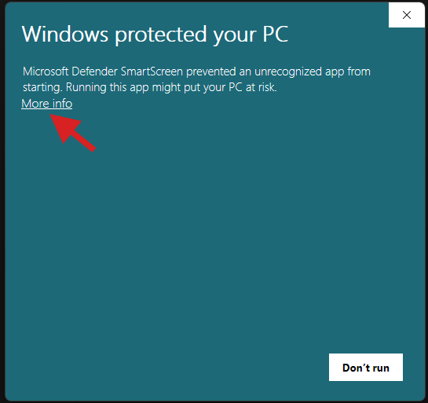
  4. Click on "Run anyway"  
     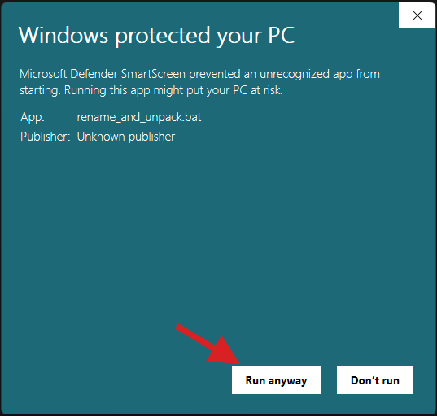
  5. The batch file will automatically rename all .ZIP files by removing special characters from the file names (to prevent any issues) and then extract all ZIP files.
  6. Once the process is complete, you’ll see a confirmation message in the command line window.  
     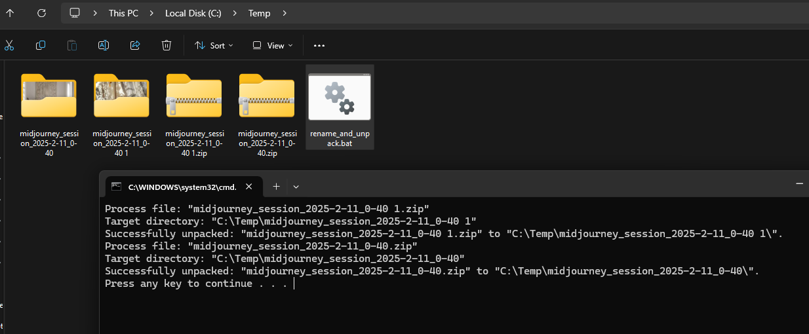
  7. You can delete all ZIP files and the "rename_and_unpack.bat" file now, as you no longer need them for the next steps.  
     If you ever need them again, you can find them in the Recycle Bin.
* If needed, sort your images into folders named after the corresponding KWs from your overview sheet for easier processing.  
  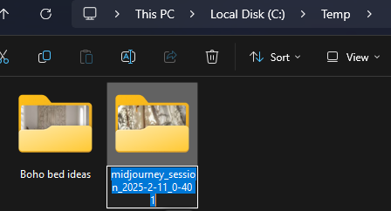

## **Step 5: Post-process images with xnConvert**

* Download xnConvert (<https://www.xnview.com/en/xnconvert/#downloads>), install and start it  
  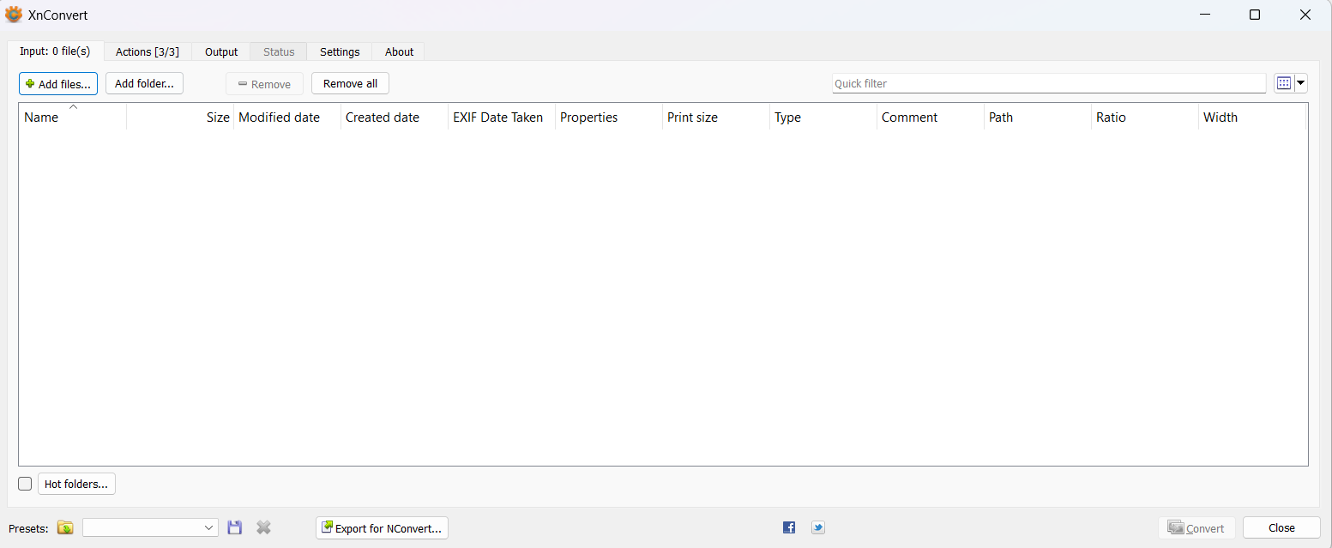
* Click on "Add folder", select your working folder (e.g., C:/Temp), and then click "Select Folder".  
  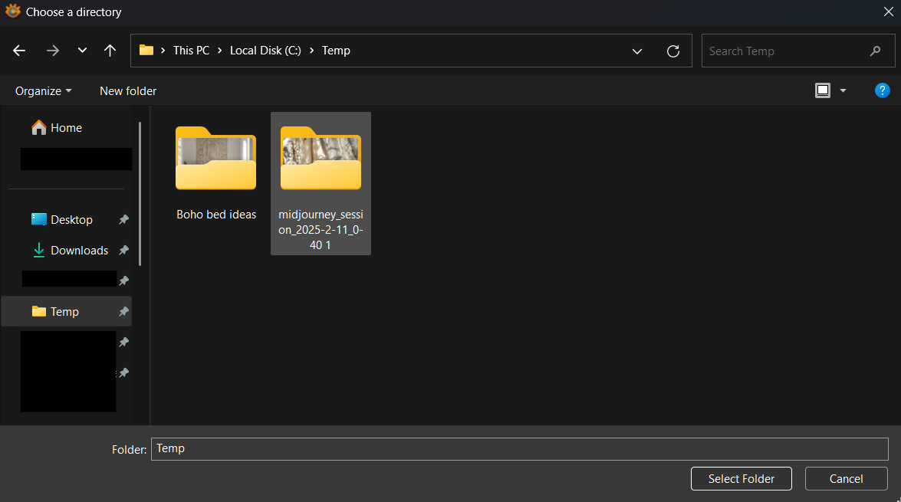
* xnConvert will display the total number of images, allowing you to verify that everything is correct.  
  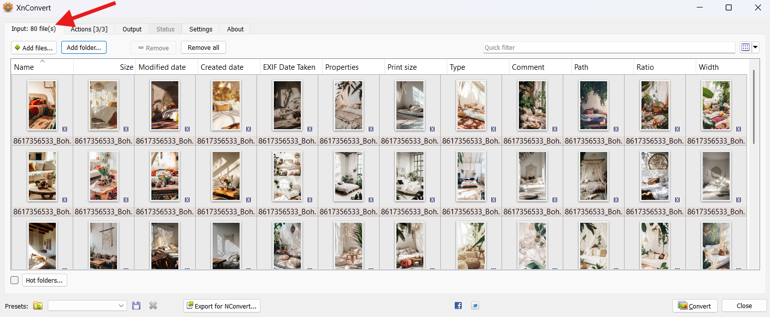
* Configure Output Settings:
  + Navigate to the "Output" tab and configure it as shown.
  + Important: Uncheck the box for "Preserve Metadata" to ensure that xnConvert removes any unwanted data (e.g., Midjourney username, prompt).
* 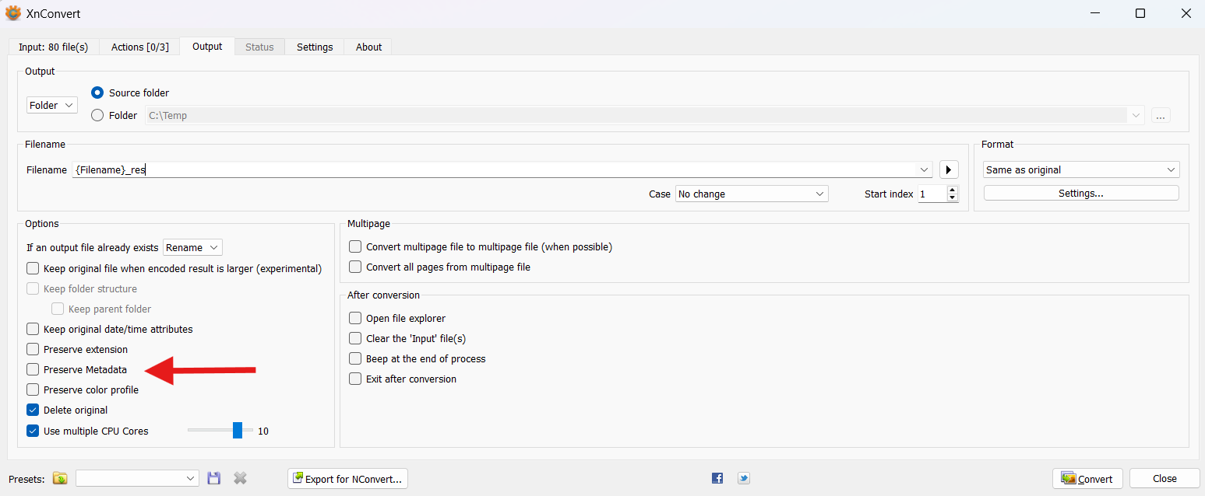
* Click "Convert", confirm with "Yes", and xnConvert will begin processing.  
  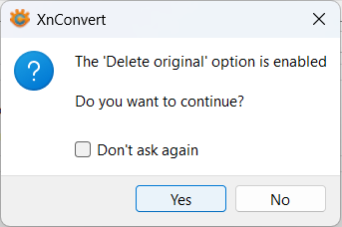
* xnConvert will now convert all images into new files while stripping out any unnecessary metadata.  
  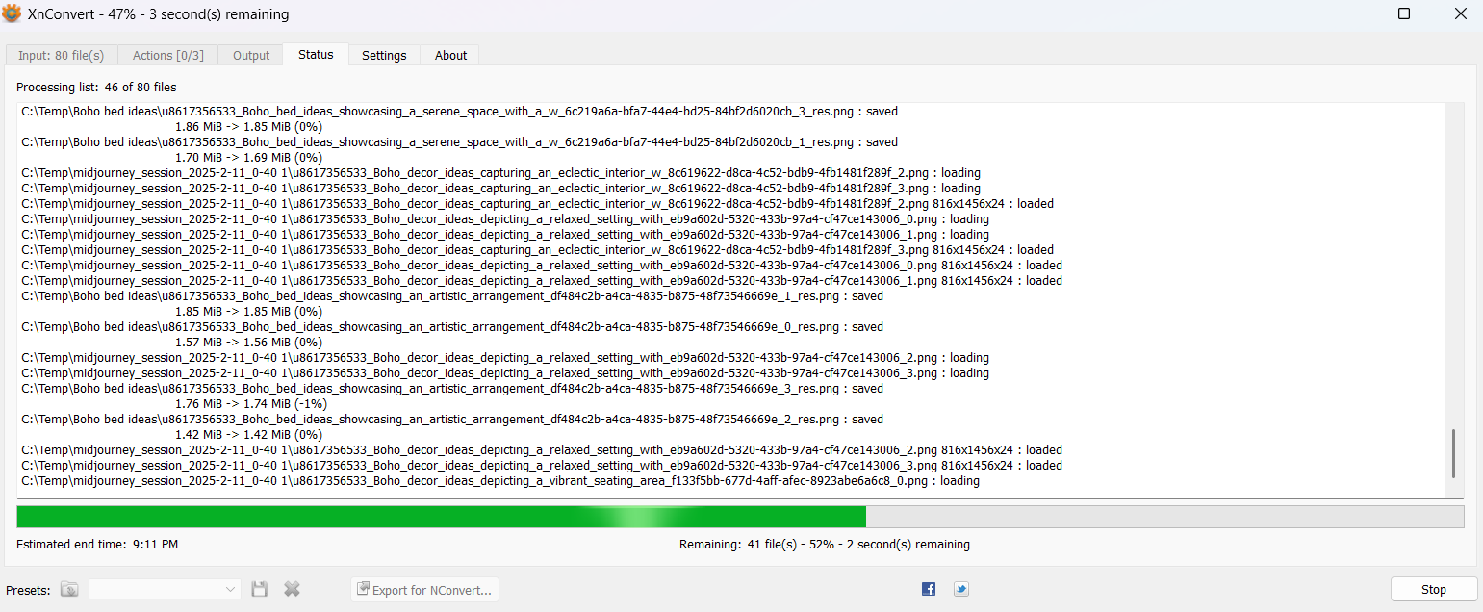

## **Step 6: Shuffle and rename files**

* To prevent too many similar images from appearing in sequence, it's best to shuffle the images within each keyword folder. Additionally, file names need to be renamed, as they contain unnecessary details like the Midjourney username and prompt.  
  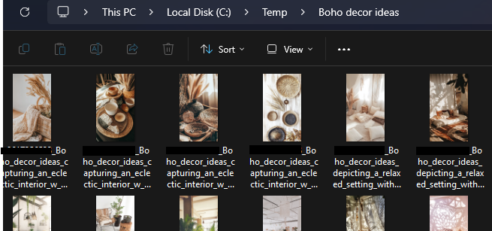
* What This Script Does:
  1. It goes into each subfolder.
  2. It shuffles all images inside.
  3. It renames them based on the subfolder name (= keyword).
  4. It renumbers them for a more natural and clean structure.
  5. [shuffle_and_rename_files_in_subfolders.bat(3.6 KB)](https://s3.us-west-2.amazonaws.com/content.podia.com/98lnfuxy1hij448odnt3o1mxsc25)
* How to Use It:
  1. Download the batch file "shuffle_and_rename_files_in_subfolders.bat".
  2. Copy the file into the same folder where all ZIP files are located (e.g., C:/Temp).  
     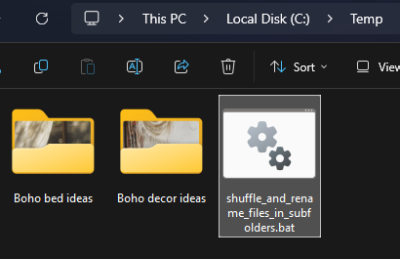
  3. Run the batch file.
  4. If you get a security warning the first time, click "More info" and proceed.  
     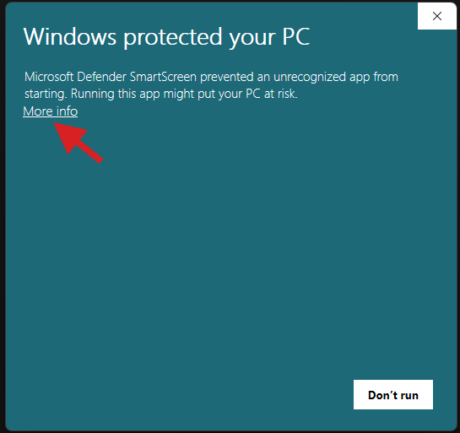
  5. Then click on "Run anyway"  
     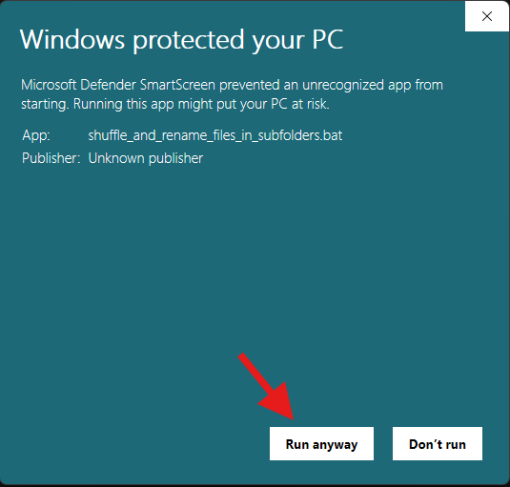
  6. 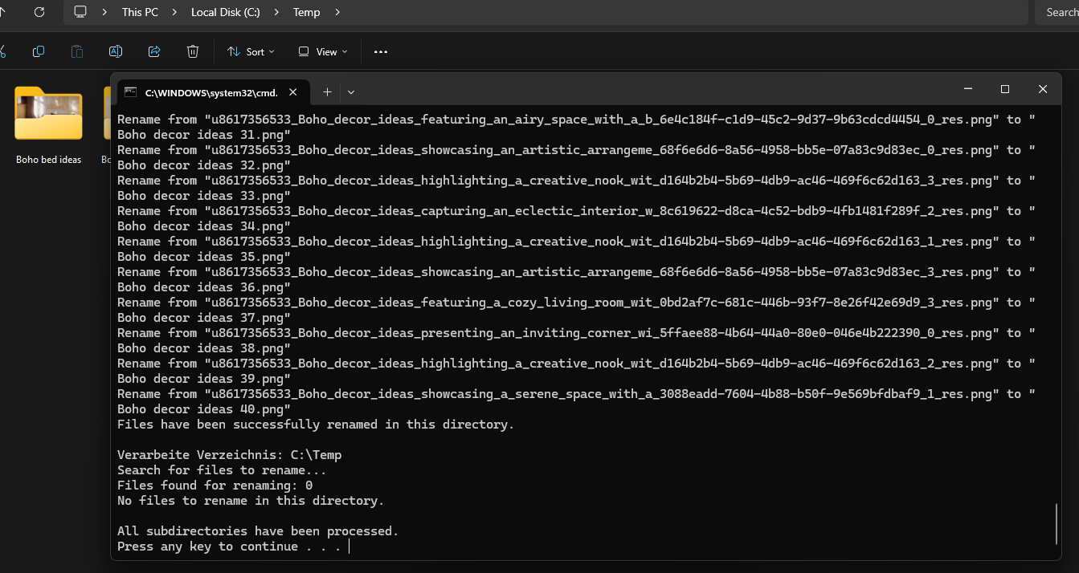
  7. Now you have a fantastic result, ready for Pinterest.  
     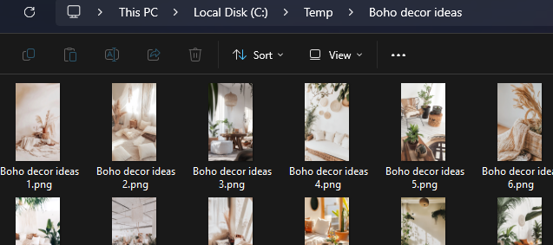

## **Step 7: Upload images to Google Drive**

* Instead of uploading each finished image directly to Pinterest one by one, it’s much more efficient to first upload them all to Google Drive. This way, you and your team have all images stored in a central location for easy access.
* Download & Install Google Drive for Desktop and connect it to your Google account.
  + After installation, a new drive (usually G:) will appear on your PC.
* 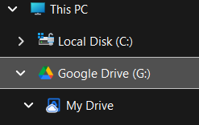
* Copy Files
  + Move the finished image folders (from Step 3) into your local Google Drive folder.
* 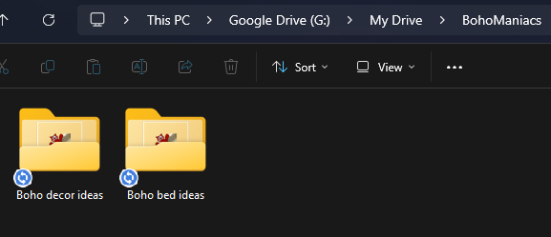
* Automatic Upload
  + Google Drive for Desktop will automatically sync the files to your cloud storage.
  + To check the upload status, click on the Google Drive icon.
* 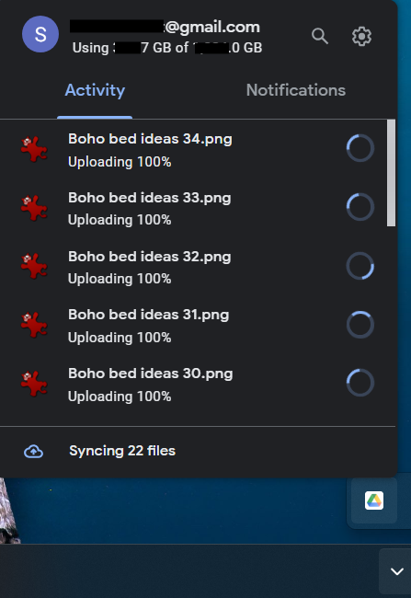
* If you see this success message, everything has been successfully transferred.  
  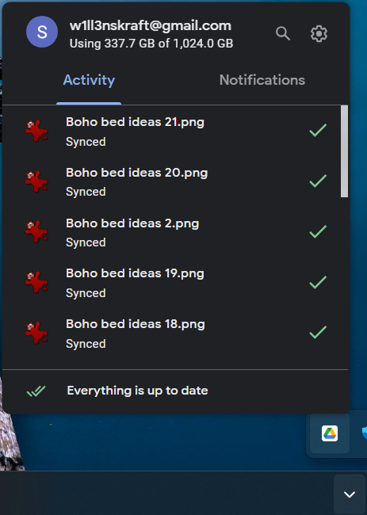
* Clean Up
  + Once the upload is complete, you can safely delete all files from your local work folder (e.g., C:/Temp).